### COVID-19 疫苗在美国大型综合卫生系统中长达 6 个月的有效性：一项回顾性队列研究

[Effectiveness of mRNA BNT162b2 COVID-19 vaccine up to 6 months in a large integrated health system in the USA a retrospective cohort study.pdf](https://bookcafe.yuntsg.com/ueditor/jsp/upload/file/20211205/1638670260581060911.pdf" \o "Effectiveness of mRNA BNT162b2 COVID-19 vaccine up to 6 months in a large integrated health system in the USA a retrospective cohort study.pdf)

Introduction

介绍

In a pivotal randomised controlled trial, the BNT162b2 mRNA vaccine (tozinameran, Pfizer–BioNTech) showed 95% or greater efficacy against symptomatic and severe COVID-19 disease due to SARS-CoV-2. In the early months after its introduction, BNT162b2 has been shown to be highly effective in the real-world setting and to have had a large public health effect on reducing infections, hospital admissions, and deaths at a time when the alpha (B.1.1.7) variant was the predominant strain in Israel, the USA, Canada, the UK, and Qatar.

在一项关键的随机对照试验中，BNT162b2 mRNA 疫苗（tozinameran，Pfizer–BioNTech）对由 SARS-CoV-2 引起的有症状和严重的 COVID-19 疾病显示出 95% 或更高的疗效。 在推出后的最初几个月，BNT162b2 已被证明在现实环境中非常有效，并且在 alpha (B.1.1 .7) 变种是以色列、美国、加拿大、英国和卡塔尔的主要菌株。

The continual emergence of SARS-CoV-2 variants has raised concern that COVID-19 vaccines could have reduced effectiveness against new viral strains; however, BNT162b2 has shown robust amounts of neutralising antibodies against all variants of concern evaluated to date. Moreover, confirmatory, real-world studies have shown high effectiveness of two doses of BNT162b2 against COVID-19, especially severe disease, caused by variants of concern alpha, beta (B.1.351), and delta in various settings.

SARS-CoV-2 变种的不断出现引起了人们的担忧，即 COVID-19 疫苗可能会降低对新病毒株的有效性；然而，BNT162b2 已显示出针对迄今为止评估的所有关注变体的大量中和抗体。此外，验证性的真实世界研究表明，两种剂量的 BNT162b2 对 COVID-19 具有很高的有效性，尤其是在各种情况下由关注的 alpha、beta (B.1.351) 和 delta 变异引起的严重疾病。

After global transmission of the delta variant in June and July, 2021, reports describing reduced effectiveness of BNT162b2 (and other COVID-19 vaccines) against SARS-CoV-2 infections caused by the delta variant began to surface from Israel, Qatar, and the USA.

在 2021 年 6 月和 7 月全球传播 delta 变体后，以色列、卡塔尔、美国和其他国家开始浮出水面，报告描述 BNT162b2（和其他 COVID-19 疫苗）对由 delta 变体引起的 SARS-CoV-2 感染的有效性降低。

The emergence of the delta variant, however, might not be the primary driver of reported declines in effectivenessagainst SARS-CoV-2 infections and increasing rates of breakthrough infections among individuals who are fully vaccinated. In Israel, Qatar, and the USA, for example, widespread dissemination of the delta variant also coincided with the time period during which many individuals at high risk who were fully vaccinated first (eg, health-care workers, individuals who were immunocompromised, and older people) were approaching 6 months since the receipt of their second dose. Thus, waning of vaccine-induced immunity, which was observed in the pivotal randomised controlled trial before the emergence of the delta variant, is an important factor to consider in the context of reported declines in effectiveness.

然而，delta 变体的出现可能不是所报告的针对 SARS-CoV-2 感染的有效性下降和完全接种疫苗的个体中突破性感染率增加的主要驱动因素。例如，在以色列、卡塔尔和美国，delta 变体的广泛传播也恰逢许多高危人群首先接种疫苗的时间段（例如，卫生保健工作者、免疫功能低下的人和 老年人）自接受第二剂以来已接近 6 个月。因此，在 delta 变体出现之前的关键随机对照试验中观察到疫苗诱导的免疫力减弱，是在报告的有效性下降的背景下需要考虑的重要因素。

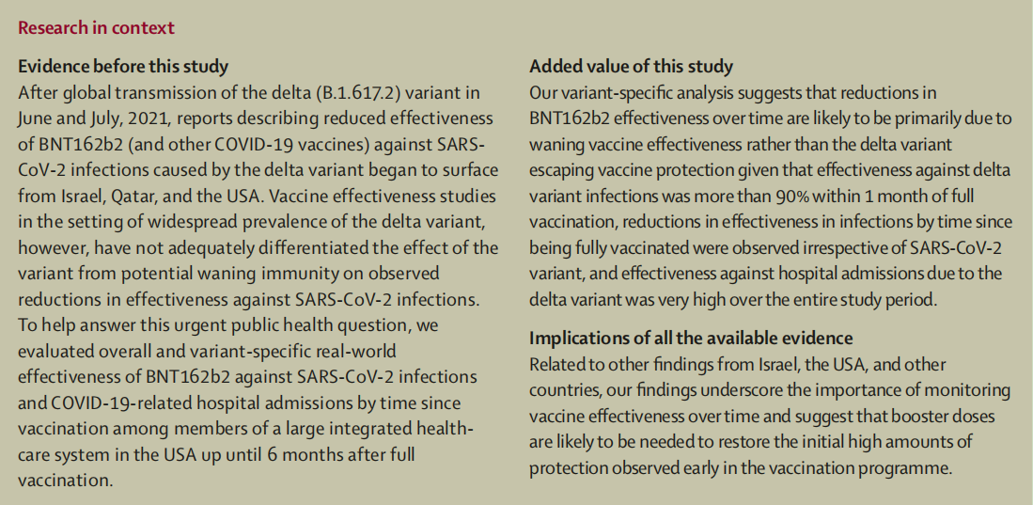

Vaccine effectiveness studies in the setting of high prevalence of the delta variant have not adequately differentiated the effect of the delta variant from potential waning immunity on observed reductions in effectiveness against SARS-CoV-2 infections. This distinction is essential to inform the need for booster doses and to establish what the antigenic composition of future vaccines should be. To help answer this urgent publichealth question, we aimed to evaluate overall and variantspecific real-world effectiveness of BNT162b2 against SARS-CoV-2 infections and COVID-19-related hospital admissions by time since vaccination among members of a large integrated health-care system in the USA.

在 delta 变体高流行的情况下的疫苗有效性研究没有充分区分 delta 变体与潜在减弱的免疫力对观察到的针对 SARS-CoV-2 感染的有效性降低的影响。这种区别对于告知加强剂量的必要性以及确定未来疫苗的抗原组成应该是什么至关重要。为了帮助回答这个紧迫的公共卫生问题，我们旨在评估 BNT162b2 对 SARS-CoV-2 感染和 COVID-19 相关住院人数的整体和变异特异性真实世界的有效性，自接种疫苗以来，大型综合医疗系统的成员之间 在美国。

Methods

方法

Study design and participants

研究设计和参与者

In this retrospective cohort study, we analysed electronic health records from the Kaiser Permanente Southern California (KPSC) health-care system (CA, USA) to assess the effectiveness of the BNT162b2 vaccine against SARS-CoV-2 infections and COVID-19-related hospital admissions. The study population consisted of all KPSC members aged 12 years and older. The start of the study period corresponded to the date the first doses of BNT162b2 were administered to KPSC members. The test-negative design described in the study protocol will be performed in future work.

在这项回顾性队列研究中，我们分析了南加州凯撒永久医疗（KPSC）医疗系统（CA，美国）的电子健康记录，以评估BNT162b2疫苗对SARS-CoV-2感染和与COVID-19相关的住院治疗的有效性。研究人群包括所有12岁及以上的KPSC成员。研究期的开始与KPSC成员首次服用BNT162b2的日期一致。研究方案中描述的试验阴性设计将在未来的工作中进行。

KPSC is an integrated health-care organisation with more than 4·7 million members, representative of the socioeconomic and racial and ethnic diversity of the area’s population. KPSC electronic health records integrate clinical data including diagnostic, pharmacy, laboratory, and vaccination history information across all settings of care. Care delivered to members outside of the KPSC system is also captured, as outside providers must submit detailed claims to KPSC for reimbursement by the health plan.

KPSC 是一个综合性医疗保健组织，拥有超过 4·7 万名成员，代表了该地区人口的社会经济和种族多样性。 KPSC 电子健康记录整合了临床数据，包括诊断、药学、实验室和疫苗接种史信息 在所有护理环境中。 向 KPSC 系统之外的成员提供的护理也被捕获，因为外部提供者必须向 KPSC 提交详细的索赔，以获得健康计划的报销。

Participants were required to have 1 year or more of membership (allowing a 31-day gap during previous membership to allow for potential delays in renewal) to determine comorbidities and medical history. Patients with documentation requesting removal from all research studies were excluded. The study protocol was reviewed and approved by the KPSC institutional review board, which waived requirement for informed consent (number 12816).

参与者被要求拥有 1 年或更长时间的会员资格（允许在之前的会员资格期间有 31 天的间隔以允许潜在的延期更新）以确定合并症和病史。有文件要求从所有研究中删除的患者被排除在外。研究方案由 KPSC 机构审查委员会审查和批准，该委员会免除了知情同意的要求（编号 12816）。

Procedures

程序

COVID-19 vaccines were provided to KPSC members at no cost following emergency use authorisation. Any COVID-19 vaccines administered to members outside of the KPSC system during the study period were captured using batch queries to the California Immunization Registry. California providers are required by law to report all COVID-19 vaccine administrations to the registry every 24 h. KPSC followed the state of California guidance in rolling out COVID-19 vaccines, first making vaccines available to health-care workers in December, 2020.Vaccines were then progressively made available to older people, individuals with underlying health conditions, and essential workers. By April, 2021, anyone aged 16 years or older was eligible to receive the vaccine. Those aged 12–15 years became eligible in May, 2021.

在获得紧急使用授权后，向 KPSC 成员免费提供了 COVID-19 疫苗。在研究期间向 KPSC 系统之外的成员接种的任何 COVID-19 疫苗都是使用对加利福尼亚免疫登记处的批量查询来捕获的。加州法律要求提供者每 24 小时向登记处报告所有 COVID-19 疫苗管理情况。KPSC 遵循加利福尼亚州推出 COVID-19 疫苗的指导方针，首先于 2020 年 12 月向卫生保健工作者提供疫苗。然后逐步向老年人、有潜在健康状况的个人和基本工作人员提供疫苗。到 2021 年 4 月，任何年满 16 岁或以上的人都有资格接种疫苗。12-15 岁的人于 2021 年 5 月符合资格。

The primary exposure was full vaccination with BNT162b2, defined as receiving two doses of BNT162b2 with 7 days or more after the second dose. Individuals were considered partially vaccinated if they received only one dose with 14 days or more after the first dose or if they received two doses with less than 7 days after the second dose. Individuals were considered unvaccinated until receipt of their first dose of BNT162b2, or until censoring at disenrolment, death, or receipt of another COVID-19 vaccine.

主要暴露是完全接种 BNT162b2，定义为在第二次接种后 7 天或更长时间接受两剂 BNT162b2。如果个人在第一剂接种后 14 天或更长时间内仅接种一剂疫苗，或者如果他们在第二剂接种后不到 7 天接种了两剂疫苗，则认为他们已部分接种。在收到第一剂 BNT162b2 之前，或在退出、死亡或收到另一种 COVID-19 疫苗时进行审查之前，个人被视为未接种疫苗。

Outcomes

结果

Outcomes comprised SARS-CoV-2 infection defined as testing positive for SARS-CoV-2 via a PCR test from any sample (ie, bronchial lavage, nasopharyngeal or nasal swab, oropharyngeal swab, throat swab, saliva, sputum, or tracheal aspirate) in any clinical setting regardless of the presence of symptoms (see appendix p 1), and COVID-19-related hospital admission defined as a hospital admission with a positive SARS-CoV-2 PCR test that was conducted between 14 days before and 3 days after the date of hospital admission.

结果包括 SARS-CoV-2 感染，定义为通过 PCR 测试从任何样本（即支气管灌洗液、鼻咽或鼻拭子、口咽拭子、咽喉拭子、唾液、痰或气管抽吸物）中检测出 SARS-CoV-2 阳性在任何临床环境中，无论是否存在症状（见附录 p 1），以及 COVID-19 相关住院定义为住院前 14 天至 3 天之间进行的 SARS-CoV-2 PCR 检测呈阳性入院日期后。

All PCR-positive SARS-CoV-2 laboratory specimens collected between March 4 and July 21, 2021, were processed for whole genome sequencing and viral lineage designation (appendix p 1). A small number of archived specimens (n=148) collected before March 4, 2021, were also included. For those with multiple positive samples, the first successfully sequenced sample was included in analyses.

对 2021 年 3 月 4 日至 7 月 21 日期间收集的所有 PCR 阳性SARS-CoV-2实验室标本进行了处理，以进行全基因组测序和病毒谱系指定（附录 p 1）。2021 年 3 月 4 日之前收集的少量存档标本 (n=148) 也包括在内。对于那些有多个阳性样本的人，第一个成功测序的样本被纳入分析。

Statistical analysis

统计分析

Using descriptive statistics, we described the distribution of demographic and clinical characteristics of the study cohort by BNT162b2 vaccination status and history of SARS-CoV-2 infection. Among those who tested positive for SARS-CoV-2, we described study population characteristics by infecting strain (ie, delta, other variant, failed sequencing). Analyses of specimens that failed sequencing were not specified in the protocol but were added due to sufficient sample size and to better understand potential bias in the sequenced sub-sample. Median time since full vaccination was also described. Hazard ratios (HRs) with 95% CIs from an unadjusted Cox model with time-varying covariates were estimated comparing rates of SARS-CoV-2 infection and COVID-19-related hospital admissions among fully vaccinated and partially vaccinated individuals to those who were unvaccinated. BNT162b2 vaccination status was categorised as time-varying, with all participants entering the cohort as unvaccinated. Follow-up time was censored at the time of disenrolment from KPSC, death, receipt of any other newly licensed or investigational COVID-19 vaccine or prophylactic agent other than BNT162b2, or receipt of more than two doses of BNT162b2. Unexposed person-time consisted of follow-up time of those never vaccinated against COVID-19, as well as time contributed by participants before being vaccinated or censored. To assess durability, vaccine effectiveness was estimated at monthly intervals after participants were fully vaccinated with BNT162b2. Sufficient sample size allowed for monthly estimates rather than the 3-month intervals specified in the protocol. Calendar time was included in all models (crude and adjusted) as the underlying time scale to allow the baseline hazard to vary flexibly as vaccine eligibility, testing practices, non-pharmaceutical interventions, lockdown requirements, disease activity, and COVID-19 treatment changed over time. The estimated hazard for a model with time-varying covariates does not have the direct relationship with cumulative incidence that the standard Cox model does, as cumulative incidence depends on the entire history of the time-varying covariate for all patients. Thus, the vaccine effectiveness estimates from these models will not match a crude rate ratio calculated using events or person-time (appendix pp 7–8). With calendar time as the timescale, both unadjusted and adjusted models compare those who are unvaccinated on each calendar date to those who are vaccinated on that same date. The adjusted Cox model extends this, effectively comparing each vaccinated person on a given date to a person with the same covariates who is unvaccinated as of that date.

使用描述性统计，我们通过 BNT162b2 疫苗接种状态和 SARS-CoV-2 感染史描述了研究队列的人口统计学和临床特征的分布。在那些对 SARS-CoV-2 检测呈阳性的人中，我们通过感染菌株（即 delta、其他变体、测序失败）描述了研究人群特征。协议中没有规定对测序失败的样本进行分析，但由于样本量充足，并且为了更好地了解测序子样本中的潜在偏差而添加了这些样本。还描述了自完全接种疫苗后的中位时间。来自具有时变协变量的未调整 Cox 模型的 95% CI 的风险比 (HR) 被估计，比较完全接种疫苗和部分接种疫苗的个体与未接种疫苗的个体之间的 SARS-CoV-2 感染率和 COVID-19 相关住院率. BNT162b2 疫苗接种状态被归类为随时间变化的，所有进入队列的参与者都未接种疫苗。在 KPSC 退出、死亡、接受任何其他新许可或研究性 COVID-19 疫苗或 BNT162b2 以外的预防剂或接受两剂以上 BNT162b2 时，对随访时间进行审查。未暴露的人时间包括那些从未接种过 COVID-19 疫苗的人的随访时间，以及参与者在接种疫苗或审查之前贡献的时间。为了评估持久性，在参与者完全接种 BNT162b2 后，每隔一个月评估一次疫苗有效性。足够的样本量允许每月估计，而不是协议中规定的 3 个月间隔。所有模型（粗略和调整后）都包含日历时间作为基础时间尺度，以允许基线危害随着疫苗资格、测试实践、非药物干预、锁定要求、疾病活动和 COVID-19 治疗的变化而灵活变化时间。具有时变协变量的模型的估计风险与标准 Cox 模型的累积发生率没有直接关系，因为累积发生率取决于所有患者的时变协变量的整个历史。因此，这些模型的疫苗有效性估计将与使用事件或人-时间计算的粗率比率不匹配（附录第 7-8 页）。以日历时间为时间尺度，未调整和调整的模型都将在每个日历日期未接种疫苗的人和在同一日期接种疫苗的人进行比较。调整后的 Cox 模型扩展了这一点，有效地将给定日期的每个接种疫苗的人与截至该日期未接种疫苗的具有相同协变量的人进行了比较。

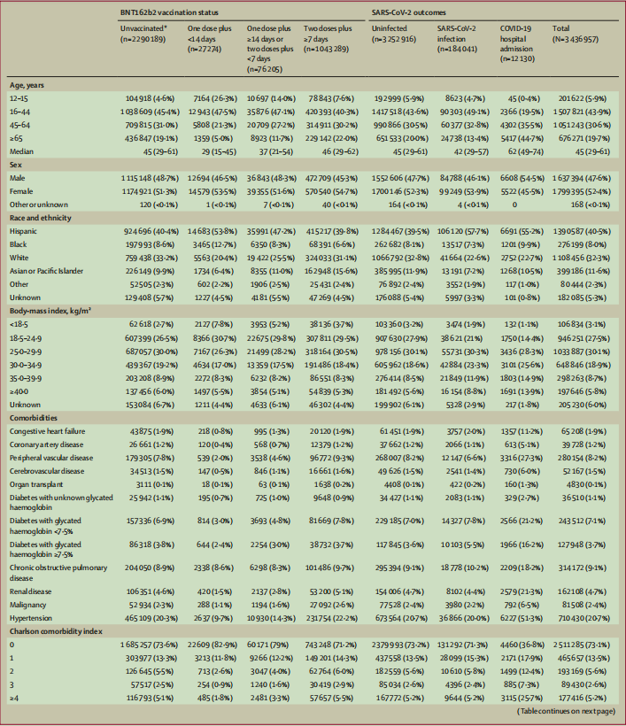

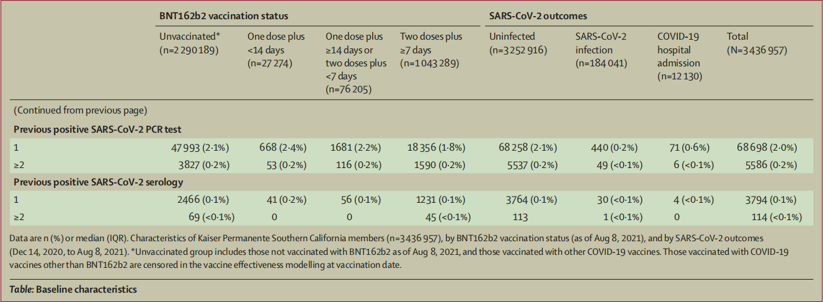

Adjusted HRs and 95% CIs were estimated by including all measured covariates in the Cox models with time-varying vaccination status. Variables included in the multivariable models were age, sex, race and ethnicity, previous PCR-positive SARS-CoV-2, previous health-care utilisation (inpatient, outpatient, emergency department, or virtual), body-mass index, acute myocardial infarction, congestive heart failure, cerebrovascular disease, peripheral vascular disease, organ transplant, diabetes, malignancy, renal disease, chronic obstructive pulmonary disease, hypertension, Charlson comorbidity index, influenza vaccination in the year before index date, pneumococcal vaccination in the 5 years before index date, and neighbourhood deprivation index30 to capture differences in neighbourhood level socioeconomic status. The inclusion of all pre-specified covariates, as requested by the US Food and Drug Administration, differs from the backward selection method outlined in the protocol. Robust variance was computed to account for clustering introduced by including neighbourhood deprivation index in the model. For all models, vaccine effectiveness was calculated as: (1–HR) multiplied by100%. Due to limitations in sample size, variant-specific vaccine effectiveness analyses were not stratified by age, were estimated only up to 4 months for SARS-CoV-2 infections, and were not stratified by month for COVID-19-related hospital admissions. Statisticalcomparisons of vaccine effectiveness by time since vaccination were made using Wald χ² tests for contrasts within Cox models. Vaccine effectiveness for delta and other variants could not be directly compared in the same regression model. The difference between delta variant vaccine effectiveness versus other variant vaccine effectiveness was compared using independent Z tests on the log HRs, which are conservative as the vaccine effectiveness for COVID-19 variants is positively correlated in the same population. All analyses were performed using SAS Enterprise Guide statistical software, version 7.1. This study was registered with ClinicalTrials.gov,NCT04848584.

调整后的 HR 和 95% CI 是通过在 Cox 模型中包括所有测量的协变量来估计的，这些协变量具有随时间变化的疫苗接种状态。多变量模型中包含的变量包括年龄、性别、种族和民族、既往 PCR 阳性 SARS-CoV-2、既往医疗保健利用（住院、门诊、急诊科或虚拟）、体重指数、急性心肌梗塞, 充血性心力衰竭, 脑血管疾病, 外周血管疾病, 器官移植, 糖尿病, 恶性肿瘤, 肾病, 慢性阻塞性肺疾病, 高血压, Charlson 合并症指数, 指数日期前一年接种流感疫苗, 指数前五年接种肺炎球菌疫苗日期和邻里剥夺指数 30，以捕捉邻里社会经济地位的差异。根据美国食品和药物管理局的要求，包含所有预先指定的协变量与协议中概述的向后选择方法不同。计算稳健方差以解释通过在模型中包含邻里剥夺指数而引入的聚类。对于所有模型，疫苗有效性的计算方式为：(1–HR) 乘以 100%。由于样本量的限制，变体特异性疫苗有效性分析未按年龄分层，估计 SARS-CoV-2 感染最多仅 4 个月，并且未按月对 COVID-19 相关住院进行分层。使用 Wald χ² 检验对 Cox 模型内的对比进行自接种以来疫苗有效性的统计比较。无法在同一回归模型中直接比较 delta 和其他变体的疫苗有效性。使用独立 Z 检验对 log HR 比较了 delta 变体疫苗有效性与其他变体疫苗有效性之间的差异，这是保守的，因为 COVID-19 变体的疫苗有效性在同一人群中呈正相关。所有分析均使用 SAS Enterprise Guide 统计软件 7.1 版进行。本研究已在 ClinicalTrials.gov 注册，NCT04848584。

Role of the funding source

资金来源的作用

The funder of the study approved the study design, and participated in data interpretation and writing of the report.

该研究的资助者批准了研究设计，并参与了数据解释和报告的撰写。

Results

结果

The study period ran from Dec 14, 2020, to Aug 8, 2021. As of Dec 14, 2020, of 4920549 individuals assessed for eligibility there were 3436957 members of KPSC who fulfilled the inclusion criteria of age 12 years or older with membership of 1 year or longer who were included in the study cohort. Median age was 45 years (IQR 29–61), 1799395 [52·4%] participants were female and 1637394 [47·6%] were male. 1390587 (40·5%) participants were Hispanic, 1108456 (32·3%) were white, 399186 (11·6%) were Asian or a Pacific Islander, and 276199 (8·0%) were Black. In the year before the study start date, 74284 (2·2%) of 3436957 participants had one or more positive SARS-CoV-2 PCR tests, and 543628 (15·8%) had one or more negative PCR tests (table).

研究时间为 2020 年 12 月 14 日至 2021 年 8 月 8 日。截至 2020 年 12 月 14 日，在评估合格的 4920549 个人中，有 3436957 名 KPSC 成员符合年龄 12 岁或以上的纳入标准，成员为 1 一年或更长时间被纳入研究队列。中位年龄为 45 岁 (IQR 29-61)，1799395 [52·4%] 名参与者为女性，1637394 [47·6%] 名参与者为男性。1390587 (40·5%) 名参与者是西班牙裔，1108456 (32·3%) 名白人，399186 (11·6%) 名亚洲或太平洋岛民，276199 (8·0%) 名黑人。在研究开始日期前一年，3436957 名参与者中有 74284 (2·2%) 名参与者进行了一项或多项 SARS-CoV-2 PCR 检测呈阳性，543628 名 (15·8%) 进行了一项或多项 PCR 检测呈阴性（表）。

During the study period, 184041 (5·4%) of 3436957 participants were infected with SARS-CoV-2, among whom 12130 (6·6%) were admitted to hospital. A higher proportion of the individuals infected with SARS-CoV-2 were younger (median age 42 years vs45 years), Hispanic (57·7% vs 39·5%), and obese (>30 kg/m²; 43·9% vs 32·7%) than those who were not infected. Among those infected with SARS-CoV-2, a higher proportion of those who were admitted to hospital for COVID-19 were older, male, had comorbidities, and had greater previous health-care utilisation than those not admitted to hospital (table, appendix p 2).

在研究期间，3436957 名参与者中有 184041 人（5·4%）感染了 SARS-CoV-2，其中 12130 人（6·6%）住院。感染 SARS-CoV-2 的个体比例较高的是年轻（中位年龄 42 岁与 45 岁）、西班牙裔（57·7% 对 39·5%）和肥胖（>30 公斤/平方米；43·9%）vs 32·7%) 比未感染者高。在感染 SARS-CoV-2 的患者中，因 COVID-19 入院的患者中，年龄较大、男性、有合并症且既往医疗保健利用率高于未入院患者的比例更高（表，附录2）。

Of 9147 specimens sent for whole genome sequencing, 236 were excluded from analyses (42 were the second sequenced samples from the same individual; 194 were the second failed samples from the same individual). Therefore, 8911 specimens were included for analyses and 5008 (56·2%) of 8911 had a sequence determined (appendix pp 3–4). We systematically submitted all PCR-positive specimens for sequencing starting March 4, 2021; however, the overall count of submitted specimens (n=8911) was 4·8% of all positive SARS-CoV-2 cases in the study (n=184041). Specimens for which a sequence could not be determined were more likely to have high cycle threshold (Ct) values (appendix p 5). The median Ct values of sequenced N, ORF1ab, and S genes were 23·0 cycles for N, 23·3 cycles for ORF1ab, and 23·4 cycles for S; the median Ct values for specimens for which a sequence could not be determined were 30·7 cycles for N, 32·4 cycles for ORF1ab, and 28·8 cycles for S. Over the study period, 1422 (28·4%) of 5008 specimens for which a sequence could be determined were the delta variant. The proportion of sequenced specimens that were delta increased from 0·6% (seven of 1192) in April, 2021, to 86·5% (923 of 1067) in July, 2021 (figure 1). The distribution of comorbidities and previous health-careutilisation was generally consistent between the variant groups in our cohort (appendix pp 3–4).

在发送进行全基因组测序的 9147 个样本中，236 个被排除在分析之外（42 个是来自同一个体的第二次测序样本；194 个是来自同一个体的第二次失败样本）。因此，8911 个样本被纳入分析，8911 个样本中的 5008 个（56·2%）已确定序列（附录第 3-4 页）。从 2021 年 3 月 4 日起，我们系统地提交了所有 PCR 阳性标本进行测序；然而，提交的样本总数 (n=8911) 占研究中所有 SARS-CoV-2 阳性病例 (n=184041) 的 4·8%。无法确定序列的样本更有可能具有高循环阈值 (Ct) 值（附录第 5 页）。已测序的N、ORF1ab和S基因的Ct中值分别为N为23·0个循环，ORF1ab为23·3个循环，S为23·4个循环；无法确定序列的样本的 Ct 值中位数为 N 30·7 个循环，ORF1ab 32·4 个循环，S 28·8 个循环。在研究期间，1422 (28·4%) 个循环可以确定序列的 5008 个样本是 delta 变体。δ 测序标本的比例从 2021 年 4 月的 0·6%（1192 个中的 7 个）增加到 2021 年 7 月的 86·5%（1067 个中的 923 个）（图 1）。合并症的分布和既往医疗保健利用在我们队列中的变异组之间大体一致（附录第 3-4 页）。

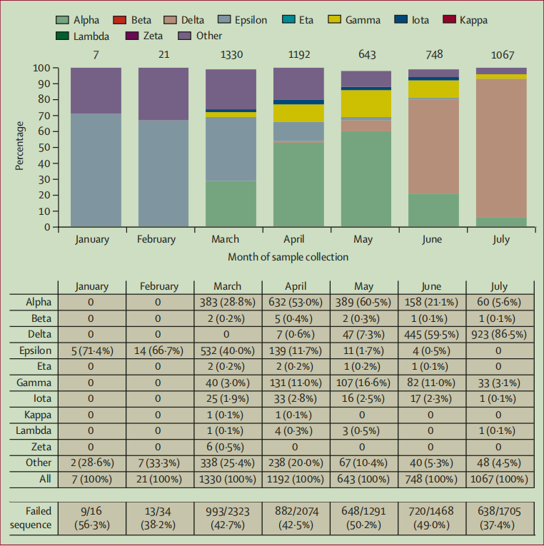

Figure 1: Distribution of variants from January to July, 2021

图1：从一月到2021年7月的变种分布

By Aug 8, 2021, 1 146 768 (33·4%) of 3 436 957 cohort members had received one or more doses of BNT162b2 (1 010 516 received ≥1 dose of mRNA-1273 [Moderna],109 911 Ad26.COV2.S [Janssen], 2972 other COVID-19 vaccines or mixed regimens, and 1 166 790 remained unvaccinated). Of these, 1 043 289 (91·0%) of 1 146 768 patients were fully vaccinated, and 76 205 (6·6%) of 1 146 768 were partially vaccinated with BNT162b2 (table). Mean time since being fully vaccinated (7 days after second dose) was 3·4 months (SD 1·8); 752 562 (72·1%) of 1 043 289 of the fully vaccinated individuals were fully vaccinated at least 3 months before.

到 2021 年 8 月 8 日，3 436 957 名队列成员中的 1 146 768 (33·4%) 接受了一剂或多剂 BNT162b2（1 010 516 接受≥1 剂 mRNA-1273 [Moderna],109 911V Ad26. .S [Janssen]、2972 种其他 COVID-19 疫苗或混合方案，还有 1 166 790 种未接种疫苗）。其中，1 146 768 名患者中有1 043 289 (91·0%) 名患者完全接种了 BNT162b2，1 146 768 名患者中有 76 205 名 (6·6%) 部分接种了 BNT162b2（表）。完全接种疫苗后的平均时间（第二次接种后 7 天）为 3·4 个月（SD 1·8）；1 043 289 名完全接种疫苗的个体中有 752 562 (72·1%) 至少在 3 个月前完全接种了疫苗。

Over the entire study period, fully vaccinated individuals had an adjusted vaccine effectiveness of 73% (95% CI 72–74) against SARS-CoV-2 infections and 90% (89–92) against COVID-19-related hospital admissions (appendix pp 6–7). Stratified by age group, the vaccine effectiveness against infection of those who were fully vaccinated was 91% (95% CI 88–93) for those aged 12–15 years and 61% (57–65) for those aged 65 years and older (appendix p 6). The age stratified vaccine effectiveness against hospital admissions was 92% (95% CI 88–95) for those aged 16–44 years, and 86% (82–88) for those aged 65 years and older (appendix p 6).

在整个研究期间，完全接种疫苗的个体针对 SARS-CoV-2 感染的调整后疫苗有效性为 73%（95% CI 72-74），针对 COVID-19 相关住院患者的调整后疫苗有效性为 90%（89-92）（附录 第 6-7 页）。按年龄组分层，12-15 岁和 65 岁及 65 岁以上人群的疫苗接种率分别为 91%（95% CI 88-93）和 61%（57-65）（附录 p 6）。对于 16-44 岁的人群，针对住院的年龄分层疫苗有效性为 92%（95% CI 88-95），对于 65 岁及以上人群为 86%（82-88）（附录第 6 页）。

Vaccine effectiveness against infection for the fully vaccinated decreased with increasing time since vaccination, declining from 88% (95% CI 86–89) during the first month after full vaccination to 47% (43–51) after 5 months (≥157 days after second dose, p<0·0001; figure 2A; appendix p 9). Individuals aged 65 years and older had a vaccine effectiveness of 80% (95% CI 73–85) within 1 month after being fully vaccinated, decreasing to 43% (30–54; p<0·0001) at 5 months after full vaccination (figure 2A; appendix p 9). Among fully vaccinated individuals of all ages, overall adjusted vaccine effectiveness estimates for COVID-19 hospital admissions were 87% (95% CI 82–91) within 1 month after being fully vaccinated, and 88% (82–92) at 5 months after full vaccination, showing no significant waning (p=0·80; figure 2B; appendix pp 9–10).

完全接种疫苗后，疫苗对感染的有效性随着接种时间的增加而降低，从完全接种后第一个月的 88% (95% CI 86-89) 下降到 5 个月后（接种后≥157 天）的 47% (43-51)。第二剂，p<0·0001；图 2A；附录 p 9)。65 岁及以上的人在完全接种疫苗后 1 个月内的疫苗有效性为 80%（95% CI 73-85），在完全接种疫苗后 5 个月降低到 43%（30-54；p<0·0001）（图 2A；附录第 9 页）。在所有年龄的完全接种疫苗的个体中，完全接种疫苗后 1 个月内 COVID-19 住院的总体调整疫苗有效性估计为 87% (95% CI 82-91)，在接种后 5 个月为 88% (82-92) 完全接种，显示没有显着减弱（p=0·80；图 2B；附录第 9-10 页）。

Overall vaccine effectiveness against infection with the delta variant for the fully vaccinated was 75% (95% CI 71–78), while overall vaccine effectiveness for other variants was 91% (88–92; appendix pp 9–10). Estimates against both delta and other variants were high within 1 month after full vaccination (vaccine effectiveness against delta 93% [95% CI 85–97] vs other variants 97% [95–99]; p=0·29). At 4 months after full vaccination, vaccine effectiveness against delta infections declined to 53% (95% CI 39–65) and vaccine effectiveness against other variants declined to 67% (45–80; p=0·25). The difference in rate of decline in vaccine effectiveness between delta and other variants was not significant (p=0·30). For specimens in which a sequence could not be determined, adjusted vaccine effectiveness after full vaccination declined from 84% [95% CI 78–88]) at less than 1 month to 47% (30–59) after 4 months (figure 3; appendix pp 10–11). Among the fully vaccinated, vaccine effectiveness against hospital admissions was 93% (95% CI 84–96) for delta and 95% (90–98) for other variants. Effectiveness against hospital admissions was lower among specimens that failed sequencing (vaccine effectiveness 77% [95% CI 67–85]; appendix pp 10–11).

完全接种疫苗的 delta 变异体感染的总体疫苗有效性为 75%（95% CI 71–78），而其他变异体的总体疫苗有效性为 91%（88–92；附录第 9–10 页）。在完全接种疫苗后的 1 个月内，对 delta 和其他变体的估计都很高（针对 delta 的疫苗有效性为 93% [95% CI 85-97]，而其他变体为 97% [95-99]；p=0·29）。在完全接种疫苗后 4 个月，针对 delta 感染的疫苗有效性下降至 53% (95% CI 39–65)，针对其他变异的疫苗有效性下降至 67% (45–80; p=0·25)。delta 和其他变体之间疫苗有效性下降率的差异不显着（p=0·30）。对于无法确定序列的标本，完全接种疫苗后调整后的疫苗有效性从不到 1 个月时的 84% [95% CI 78-88]) 下降到 4 个月后的 47% (30-59)（图 3；附录第 10-11 页）。在完全接种疫苗的人群中，对于 delta 和其他变体，针对入院的疫苗有效性为 93% (95% CI 84–96) 和 95% (90–98)。测序失败的样本对住院的有效性较低（疫苗有效性 77% [95% CI 67-85]；附录 10-11 页）。

Discussion

讨论

This retrospective cohort study conducted in a large integrated health-care system showed that individuals who were fully vaccinated with BNT162b2 had 73% (95% CI 72–74) overall effectiveness against SARS-CoV-2 infections and 90% (89–92) effectiveness against COVID-19-related hospital admissions after a mean time since being fully vaccinated of 3·4 months. Effectiveness against SARS-CoV-2 infections waned during the 6 months of this study. Effectiveness against hospital admissions in all age groups did not wane over the duration of the study. These findings are consistent with preliminary reports from the Israel Ministry of Health and US Centers for Disease Control and Prevention showing reductions in effectiveness of BNT162b2 against infections 5 months or longer after being fully vaccinated, but consistently high estimates against COVID-19-related hospital admissions and severe disease up until July, 2021. The most recent report from August, 2021,from Israel, however, suggests that some reduction in effectiveness against hospital admissions has beenobserved among older people (≥65 years) roughly 6 months after receiving the second dose of BNT162b2. Thus, long-term effectiveness data against severe outcomes should be continuously monitored in our study population and globally.

这项在大型综合医疗系统中进行的回顾性队列研究表明，完全接种BNT162b2疫苗的个体对SARS-CoV-2感染的总体有效性为73%（95%可信区间72-74），对SARS-CoV-2感染的总体有效性为90%（89-92）自完全接种疫苗3.4个月后平均一段时间后，对与新冠病毒-19相关的住院患者的有效性。在这项研究的6个月期间，对SARS-CoV-2感染的有效性有所下降。在研究期间，所有年龄组的住院治疗有效性并未减弱。这些发现与以色列卫生部和美国疾病控制和预防中心的初步报告一致，这些报告显示，在完全接种疫苗5个月或更长时间后，BNT162b2对感染的有效性降低，但对COVID-19相关的医院入院和严重疾病的估计一直持续到2021年7月。然而，2021年8月来自以色列的最新报告显示，老年人对医院入院的有效性有所下降。≥在接受第二剂BNT162b2后大约6个月。因此，在我们的研究人群和全球范围内，应对严重后果的长期有效性数据进行持续监测。

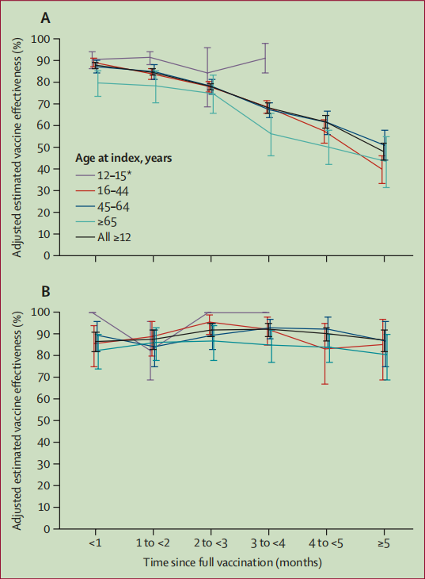

Figure 2: Adjusted estimated vaccine effectiveness against SARS-CoV-2 infection and hospital admissions

图2:SARS-CoV-2感染的调整后估计疫苗有效性和住院情况

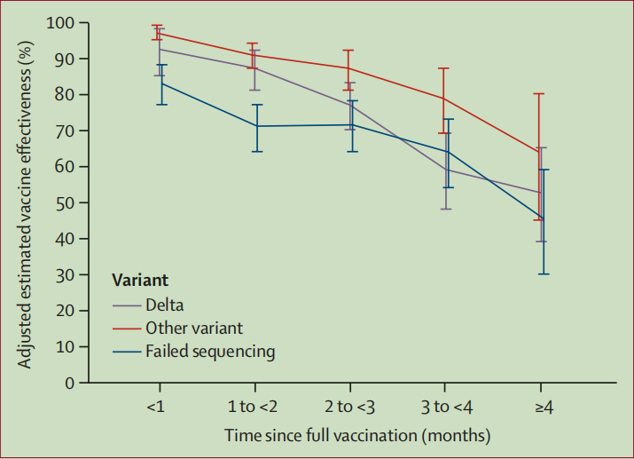

Figure 3: Adjusted estimated vaccine effectiveness against SARS-CoV-2 infection by variant

图3:SARS-CoV-2感染疫苗的调整后估计有效性（按变异）

Effectiveness of BNT162b2 against infections caused by the delta variant, which became the predominant strain in KPSC by July, 2021, was 75% (95% CI 71–78) over the study period. Effectiveness against delta infections at 1 month after being fully vaccinated was high at 93% (85–97) but fell to 53% (39–65) up to 5 months after being fully vaccinated. Effectiveness against other (non-delta) variants within 1 month of being fully vaccinated was also high at 97% (95–99) and also waned, to 67% (45–80) up to 5 months after being fully vaccinated. Effectiveness against delta-related hospital admissions over the entire study period was high, at 93% (84–96) and was similar to effectiveness against hospital admissions for other (non-delta) variants. These findings are consistent with reports from the USA and Qatar. Our variantspecific analyses suggest that reductions in vaccine effectiveness over time are likely to be primarily due to waning vaccine effectiveness rather than the delta variant escaping vaccine protection given that vaccine effectiveness against delta infections was more than 90% soon after vaccination, vaccine effectiveness against delta and other variants for hospital admissions was very high over the entire study period, and reductions in vaccine effectiveness against infection by time since being fully vaccinated were observed irrespective of the variant. We did not observe a difference in waning between variant types; however, the number of events at 3–4 months was low for analyses by variant. As such, analyses with longer follow-up to measure the rate of waning for the delta versus other variants are warranted. Related to our findings, studies from Canada and the UK have shown high effectiveness of BNT162b2 against symptomatic COVID-19 caused by the delta variant in a vaccine schedule that separates the first and second doses by 2–3 months instead of 3 weeks. This longer interval between doses could lead to higher immunological responses; however, duration of followup in these studies (<3 months) was insufficient to establish the effects of waning. Moreover, given the lower effectiveness after only one dose observed in our study and in other reports of one-dose effectiveness against variants of concern like beta or delta, delaying the second dose is not without risk.

BNT162B2对Delta变异体引起的感染的有效性在2021年7月期间成为KPSC中的主要菌株，在研究期间为75%（95% CI 71～78）。完全接种后1个月对三角洲感染的有效性高达93%（85-97），但在完全接种后5个月降至53%（39-65）。在完全接种后1个月内对其他（非三角洲）变种的有效性也很高，为97%（95-99），在完全接种后5个月内也下降到67%（45-80）。在整个研究期间，针对delta相关住院的有效性很高，为93%（84–96），与针对其他（非delta）变体住院的有效性相似。这些发现与美国和卡塔尔的报告一致。我们的差异特异性分析表明，随着时间的推移，疫苗有效性的降低可能主要是由于疫苗有效性的下降，而不是由于疫苗接种后不久，针对delta感染的疫苗有效性超过90%，delta变异逃避了疫苗保护，在整个研究期间，针对住院患者的delta和其他变体的疫苗有效性非常高，并且观察到疫苗有效性随着时间的推移而降低，因为完全接种了疫苗，而与变体无关。我们没有观察到变异类型之间衰退的差异；然而，根据变量分析，3-4个月的事件数量较低。因此，有必要进行更长时间的跟踪分析，以测量delta相对于其他变体的衰减率。与我们的2019冠状病毒疾病的研究结果相比较，加拿大和英国的研究显示，BNT162B2对由疫苗计划中Delta变体引起的症状性COVID-19的高效力，其第一和第二剂量的间隔是2至3个月而不是3周。这种较长的剂量间隔可导致较高的免疫反应；然而，这些研究的随访时间（<3个月）不足以确定衰退的影响。此外，由于在我们的研究中仅观察到一个剂量的有效性，并且在其他的剂量对β或δ关注的变异毒株的有效性的其他报告中，延迟第二剂量不是没有风险的。

Our results reiterate in a real-world US setting that vaccination with BNT162b2 remains an essential tool for preventing COVID-19, especially COVID-19-associated hospital admissions, caused by all current variants of concern. Along with other emerging evidence, our results suggest that despite early effectiveness of BNT162b2 against delta and other variants of concern, effectiveness against infection erodes steadily in the months after receipt of the second dose. Waning effectiveness and an increased number of infections 6–12 months after the second dose—along with the potential need for booster doses—was expected given that lower neutralising antibody titres during this time period have been observed in immunogenicity studies. Waning has been observed for both mRNA-based (Pfizer–BioNTech and Moderna) COVID-19 vaccines, and is consistent with studies of other coronaviruses. Reassuringly, early phase 1 data show that a third booster dose of the current BNT162b2 vaccine given 6 months after the second dose elicited neutralising antibody titres against the original SARS-CoV-2 wild-type strain, beta, and delta, which were several times higher than after two primary doses. Modelling studies have predicted that these increases in neutralising antibody titres will restore high amounts of vaccine effectiveness. Moreover, early unpublished data from an Israeli health maintenance organisation (Maccabi Health Services) suggest that a third booster dose is highly effective in a setting in which the delta variant accounts for nearly all cases. These findings suggest that boosting with the current BNT162b2 vaccine rather than a delta-specific construct might be effective. Considerations of booster doses should also account for COVID-19 supply, as priority populations in some countries or subnational settings have not yet received a primary vaccination series.

变异毒株是一种预防2019冠状病毒疾病的重要工具，尤其是COVID-19型医院入院，这是目前所有关注的变异所引起的。除了其他新的证据，我们的结果表明，尽管BNT162B2对Delta和其他变异毒株的早期疗效，抗感染的有效性在第二次剂量后几个月内逐渐侵蚀。鉴于在免疫原性研究中观察到在这段时间内中和抗体滴度较低，预计在第二次给药后6-12个月，有效性下降，感染人数增加，以及可能需要增加剂量。对于科罗娜啤酒2019冠状病毒疾病，已观察到了减弱（Fiff-BioTeCo和NeTNA）疫苗，并且与其他冠状病毒的研究一致。令人欣慰的是，第一阶段的早期数据显示，在第二次注射6个月后注射的第三次增强剂量的当前BNT162b2疫苗可产生针对原始SARS-CoV-2野生型毒株、β和δ的中和抗体滴度，比两次一次注射后高出数倍。模型研究预测，中和抗体滴度的增加将恢复疫苗的高效力。此外，来自以色列健康维护组织（Maccabi health Services）的早期未公开数据表明，在几乎所有病例都使用delta变体的情况下，第三次增强剂量是非常有效的。这些发现表明，使用目前的BNT162b2疫苗而不是delta特异性结构进行增强可能是有效的。2019冠状病毒疾病的剂量也应考虑COVID-19的供应，因为一些国家或亚国家的优先人群尚未收到初级疫苗接种系列。

Our study has potential limitations. We were unable to establish causal relationships between vaccination and COVID-19 outcomes in this observational study. Further, it is difficult to achieve a perfect balance of testing patterns and other characteristics between vaccinated and unvaccinated patients in this real-world observational study design. We attempt to address this issue by adjusting for proxies for general health-care seeking behaviour (visits across health-care settings before baseline), prior vaccination behaviour, demographics, comorbidities, and neighbourhood-level socioeconomic status. However, we did not have data for adherence to masking guidelines, social interactions, and occupation, which are likely to also affect likelihood of testing for SARS-CoV-2 either when experiencing symptoms or routinely as a preventive measure. KPSC maintained several drive-through testing clinics, did not have resource limitations on COVID-19 testing, and provided free testing to all members during the study period. We compared vaccinated and unvaccinated individuals at the same point in time, which balances the availability of testing, infection rates, and other secular inputs that might affect testing behaviours between vaccinated and unvaccinated patients to the extent possible in observational research. Effectiveness was lowest for PCR-positive specimens for which a sequence could not be determined. These specimens had higher Ct values than other PCR-positive specimens, which probably corresponded to milder or asymptomatic infections. Thus, our vaccine effectiveness estimates against SARS-CoV-2 infections and hospital admissions could be muted by mild or asymptomatic infections and are not directly comparable to estimates of effectiveness against symptomatic disease. Sequencing was more likely to fail in samples from vaccinated individuals due to lower viral loads, which could lead to an overestimate of variant-specific effectiveness. Finally, although the KPSC electronic health records might miss some vaccinations administered outside of the health system, our data capture through the California Immunization Registry minimised this effect.

我们的研究有潜在的局限性。在这项观察性研究中，我们无法确定疫苗接种与 COVID-19 结果之间的因果关系。此外，在这种现实世界的观察性研究设计中，很难在接种疫苗和未接种疫苗的患者之间实现测试模式和其他特征的完美平衡。我们试图通过调整一般医疗寻求行为（基线前跨医疗机构就诊）、先前的疫苗接种行为、人口统计学、合并症和社区级社会经济状况的代理来解决这个问题。但是，我们没有关于遵守掩蔽指南、社交互动和职业的数据，这些数据也可能影响在出现症状时或作为常规预防措施进行 SARS-CoV-2 检测的可能性。 KPSC 设有多个免下车检测诊所，在 COVID-19 检测方面没有资源限制，并在研究期间向所有成员提供免费检测。我们在同一时间点比较了接种疫苗和未接种疫苗的个体，这在观察性研究中尽可能平衡了检测的可用性、感染率和其他可能影响接种疫苗和未接种疫苗的患者之间的检测行为的长期投入。对于无法确定序列的 PCR 阳性样本，有效性最低。这些标本的 Ct 值高于其他 PCR 阳性标本，这可能对应于较轻或无症状的感染。因此，我们对 SARS-CoV-2 感染和住院的疫苗有效性估计可能会因轻度或无症状感染而减弱，并且无法与对有症状疾病的有效性估计直接比较。由于病毒载量较低，接种疫苗的个体样本中的测序更有可能失败，这可能会导致对变异特异性有效性的高估。最后，尽管 KPSC 电子健康记录可能会遗漏一些在卫生系统之外进行的疫苗接种，但我们通过加利福尼亚免疫登记处获取的数据将这种影响降至最低。

Our results show high effectiveness of BNT162b2 against hospital admissions up until 6 months after being fully vaccinated in a large, diverse cohort under real-world vaccination conditions, even in the face of widespread dissemination of the delta variant. These findings underscore the importance of continuing to prioritise improving COVID-19 vaccination rates, including in hard-to-reach communities. Effectiveness against infections was high soon after full vaccination, both for delta and other variants of concern, but waned over the study period. Although waning effectiveness against hospital admissions was not observed in our study population to date, this possibility should be carefully monitored. Our findings underscore the importance of monitoring vaccine effectiveness over time and suggest that booster doses might eventually be needed to restore the high levels of protection observed early in the vaccination programme. These factors are especially important to help control heightened transmission of the delta variant as we enter the upcoming autumn and winter viral respiratory season.

我们的结果表明，即使面对 delta 变体的广泛传播，BNT162b2 在真实世界的疫苗接种条件下，在一个大型、多样化的队列中完全接种疫苗后 6 个月内，仍具有很高的住院率。这些发现强调了继续优先提高 COVID-19 疫苗接种率的重要性，包括在难以到达的社区。在完全接种疫苗后不久，针对 delta 和其他关注的变种，对感染的有效性就很高，但在研究期间逐渐减弱。尽管迄今为止在我们的研究人群中未观察到针对住院的有效性减弱，但应仔细监测这种可能性。我们的研究结果强调了随着时间的推移监测疫苗有效性的重要性，并表明可能最终需要加强剂量以恢复高水平的在疫苗接种计划的早期观察到保护。当我们进入即将到来的秋季和冬季病毒性呼吸道季节时，这些因素对于帮助控制 delta 变体的高度传播尤为重要。